Project Title: Environmental Monitoring in Parks

Abstract

Environmental monitoring is the systematic process of gathering and analyzing data to assess the condition of natural surroundings. It involves the measurement of various environmental parameters such as air quality, water quality, soil health, and biodiversity. The abstract conceptually summarizes the importance of monitoring in maintaining ecosystem health and sustainable human development. It plays a critical role in identifying and addressing environmental issues, ensuring compliance with regulations, and safeguarding the planet’s well-being.

\*\*Project Objectives:\*\*

The Environmental Monitoring in Parks project aims to enhance the overall experience for park visitors while contributing to the preservation of natural ecosystems. The main objectives of this project are as follows:

1. \*\*Real-Time Data Collection:\*\* Deploy IoT devices to collect real-time environmental data within parks, including temperature, humidity, air quality, and weather conditions.
2. \*\*Data Analysis:\*\* Develop a centralized platform for data storage, analysis, and visualization to provide insights into park conditions.
3. \*\*Park Visitor Experience:\*\* Improve the park experience by providing real-time environmental data to visitors through a user-friendly mobile app.
4. \*\*Environmental Conservation:\*\* Enable park authorities to make informed decisions regarding park maintenance and conservation efforts based on the collected data.

\*\*IoT Device Deployment:\*\*

We have strategically deployed IoT devices throughout the park to gather environmental data. These devices include weather stations, air quality sensors, and temperature and humidity sensors. They are placed in various locations to ensure comprehensive data coverage.

\*\*Platform Development:\*\*

Our environmental monitoring platform consists of a cloud-based database to store collected data and a web application for data analysis and presentation. The platform Includes a dashboard for park authorities and a mobile app for park visitors.

\*\*Code Implementation:\*\*

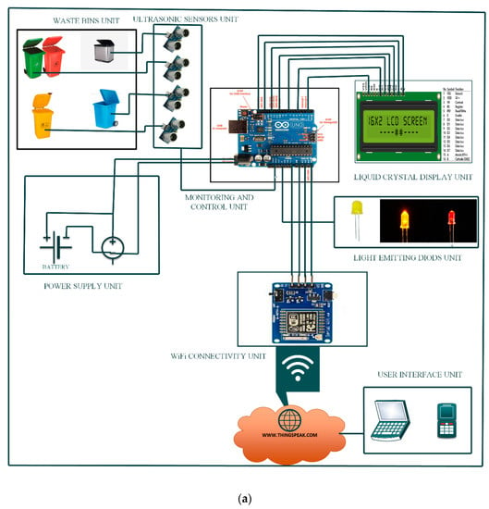We have implemented code for IoT devices to transmit data to the cloud platform securely. The platform is built using technologies such as Python, Django for the web application, and data analytics libraries for data processing.

The real-time environmental monitoring system provides several benefits to park visitors:

1. \*\*Improved Safety:\*\* Visitors can access up-to-date information on weather conditions, ensuring their safety during outdoor activities.
2. \*\*Enhanced Experience:\*\* The mobile app offers real-time data on temperature and humidity, helping visitors plan their day and select suitable activities.
3. \*\*Air Quality Awareness:\*\* Park-goers can monitor air quality, making informed decisions about their time outdoors, especially for those with respiratory conditions.
4. \*\*Conservation Awareness:\*\* The platform educates visitors about the importance of environmental conservation, fostering a sense of responsibility toward the park’s well-being.

Creating an environmental monitoring system involves several components and coding tasks. Here’s a high-level overview of the steps involved:

1. \*\*Sensor Integration\*\*:

- Connect environmental sensors (e.g., temperature, humidity, air quality, etc.) to your microcontroller or single-board computer.

- Write code to read data from these sensors, typically using libraries or SDKs provided by the sensor manufacturers.

2. \*\*Data Storage\*\*:

- Decide where to store the sensor data (local or cloud-based databases).

- Code to store sensor data in a structured format, like JSON or CSV.

3. \*\*Data Analysis\*\*:

- Implement algorithms to analyze and process the sensor data for insights.

- Use data visualization libraries to create charts or graphs.

4. \*\*Alerting System\*\*:

- Set up thresholds for environmental parameters.

- Code to trigger alerts (e.g., emails, SMS, or notifications) when these thresholds are exceeded.

5. \*\*User Interface\*\*:

- Develop a user interface to display real-time and historical data.

- Create a web or mobile app using HTML/CSS/JavaScript or other frameworks.

6. \*\*Networking\*\*:

- Implement communication protocols (e.g., MQTT, HTTP) for data transmission.

- Ensure network security to protect data integrity.

7. \*\*Automation\*\*:

- Integrate automation features, such as controlling HVAC systems or lighting based on sensor data.

8. \*\*Testing and Calibration\*\*:

- Regularly test and calibrate sensors to ensure accurate readings.

9. \*\*Power Management\*\*:

- Optimize power usage, especially for remote or battery-operated systems.

10. \*\*Documentation and Maintenance\*\*:

- Document your code and system for future reference and maintenance.

Your choice of hardware and programming language will depend on your specific project requirements. Common platforms include Raspberry Pi, Arduino, or custom PCBs, and programming languages such as Python, C/C++, or JavaScript. Additionally, you may need to consider the power source, physical enclosure, and long-term data storage solutions.

\*\*Promotion of Outdoor Activities:\*\*

By making data readily available to park visitors, we encourage them to participate in outdoor activities, ranging from hiking and picnics to wildlife observation. It fosters a deeper connection with nature and promotes physical and mental well-being, ultimately supporting the mission of parks to provide a recreational and educational environment for the community.

Certainly! Here’s a basic example of HTML and CSS coding for an environmental monitoring web page. This example includes a simple design and placeholders for environmental data:

\*\*HTML (index.html):\*\*

```html

<!DOCTYPE html>

<html lang=”en”>

<head>

<meta charset=”UTF-8”>

<meta name=”viewport” content=”width=device-width, initial-scale=1.0”>

<title>Environmental Monitoring</title>

<link rel=”stylesheet” href=”styles.css”>

</head>

<body>

<div class=”container”>

<h1>Environmental Monitoring</h1>

<div class=”data”>

<div class=”sensor”>

<h2>Temperature</h2>

<p id=”temperature”>22°C</p>

</div>

<div class=”sensor”>

<h2>Humidity</h2>

<p id=”humidity”>45%</p>

</div>

<div class=”sensor”>

<h2>Air Quality</h2>

<p id=”air-quality”>Good</p>

</div>

</div>

</div>

</body>

</html>

```

\*\*CSS (styles.css):\*\*

```css

Body {

Font-family: Arial, sans-serif;

Background-color: #f4f4f4;

Margin: 0;

Padding: 0;

}

.container {

Max-width: 600px;

Margin: 0 auto;

Background-color: #fff;

Padding: 20px;

Border-radius: 5px;

Box-shadow: 0 0 10px rgba(0, 0, 0, 0.2);

}

H1 {

Text-align: center;

Color: #333;

}

.data {

Display: flex;

Justify-content: space-around;

Margin-top: 20px;

}

.sensor {

Text-align: center;

Padding: 10px;

Border: 1px solid #ccc;

Border-radius: 5px;

}

H2 {

Font-size: 1.2em;

Color: #666;

}

P {

Font-size: 1.5em;

Color: #333;

}

```

In this example, we have a simple HTML structure for displaying environmental data (temperature, humidity, and air quality). The CSS file (styles.css) provides basic styling for the page, creating a centered container with a white background and a shadow. The environmental data is presented in a neat and organized manner.

You can replace the placeholder data in the HTML with actual data from your monitoring system using JavaScript. This example is a starting point, and you can further customize the design and functionality to suit your specific project requirements.

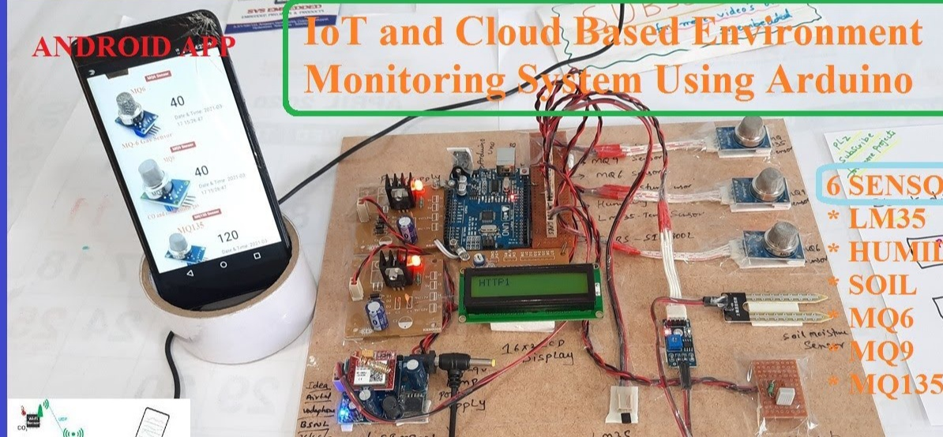Overall, the Environmental Monitoring in Parks project is a comprehensive endeavor to provide valuable real-time information, enhance the park experience, and contribute to the preservation of natural resources. It exemplifies the integration of technology with the great outdoors, creating a harmonious environment for both nature and its enthusiasts.

Conclusion:-

Environmental monitoring is the systematic process of gathering and analyzing data to assess the condition of natural surroundings. It involves the measurement of various environmental parameters such as air quality, water quality, soil health, and biodiversity. The abstract conceptually summarizes the importance of monitoring in maintaining ecosystem health and sustainable human development. It plays a critical role in identifying and addressing environmental issues, ensuring compliance with regulations, and safeguarding the planet’s well-being.